**Commentary on the Assignment Given**

**Solution 1**

1. **Introduction**

This report is based on the explanatory data analysis of the “survival from malignant melanoma” using R. The dataset consists of the measurements made on patients with malignant melanoma measurements of 205 patients with the following columns

-Time (days of survival since operation)

-Age (Age of patient in Years)

-Year (What year it was when operation was performed)

-Sex (Gender of patients)

-Ulcer (indication of ulceration)

-Thickness (Tumor thickness in mm)

Data Summary: Table 1

|  |  |  |  |  |  |  |  |
| --- | --- | --- | --- | --- | --- | --- | --- |
|  | **Time** | **Age** | **Year** | **Thickness** | **Sex** | **Status** | **Ulcer** |
| **Min** | 10 | 4. | 1962 | 0.100 | 0.000 | 1.000 | 0.000 |
| **1st Q** | 1525 | 42 | 1968 | 0.970 | 0.000 | 1.000 | 0.000 |
| **Median** | 2005 | 54 | 1970 | 1.940 | 0.000 | 2.000 | 0.000 |
| **Mean** | 2153 | 52.46 | 1970 | 2.920 | 0.385 | 1.790 | 0.439 |
| **3rd Q** | 3042 | 65 | 1972 | 3.560 | 1.000 | 2.000 | 1.000 |
| **Max** | 5565 | 95 | 1977 | 17.42 | 1.000 | 3.000 | 1.000 |
| **S. D** | 1122 | 16.67 | 2.575 | 2.959 | 0.487 | 0.551 | 0.497 |

From Table 1 it can been seen that 38% of the patient in the data are male, about 44% of the tumor was ulcerated, more than 50% of the patient survived after the operation. The average age of the patient that took the operation is 52.

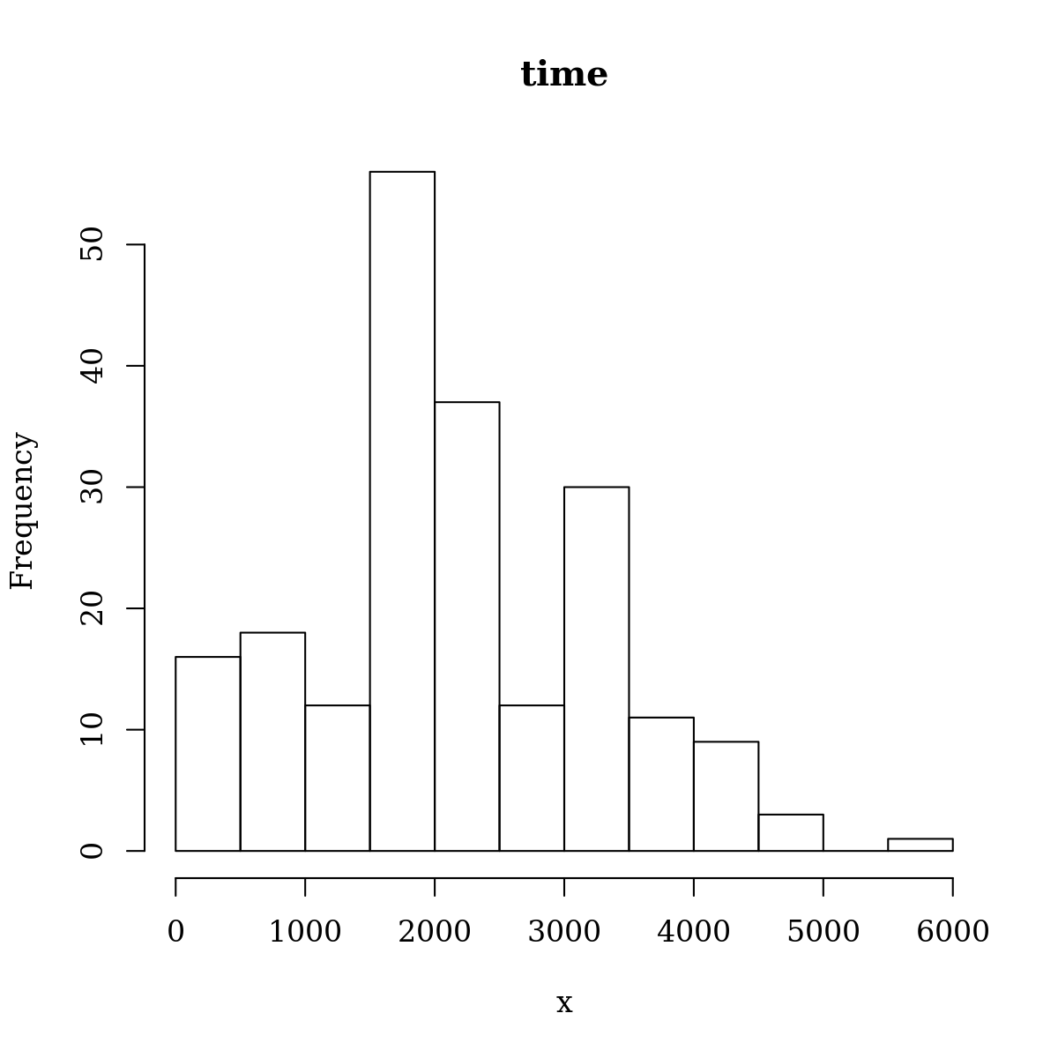**Solution 2**

Figure 2

Distribution of age in years at the time of the operation

Figure 1

Distribution of survival time in days since the operation

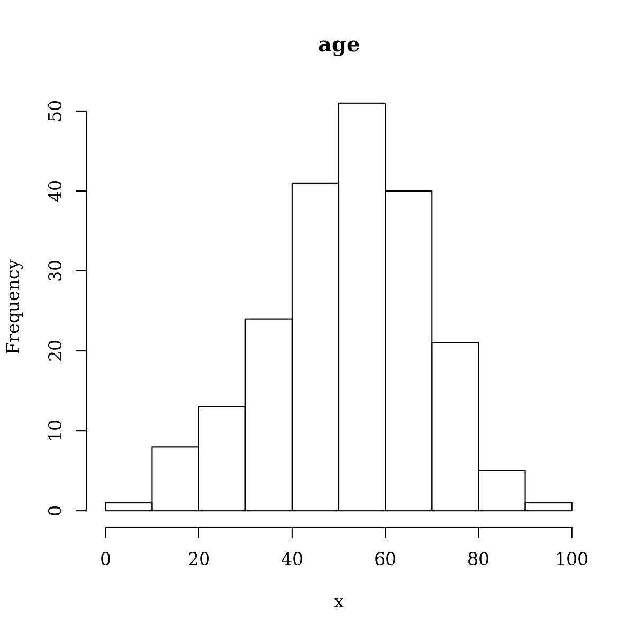

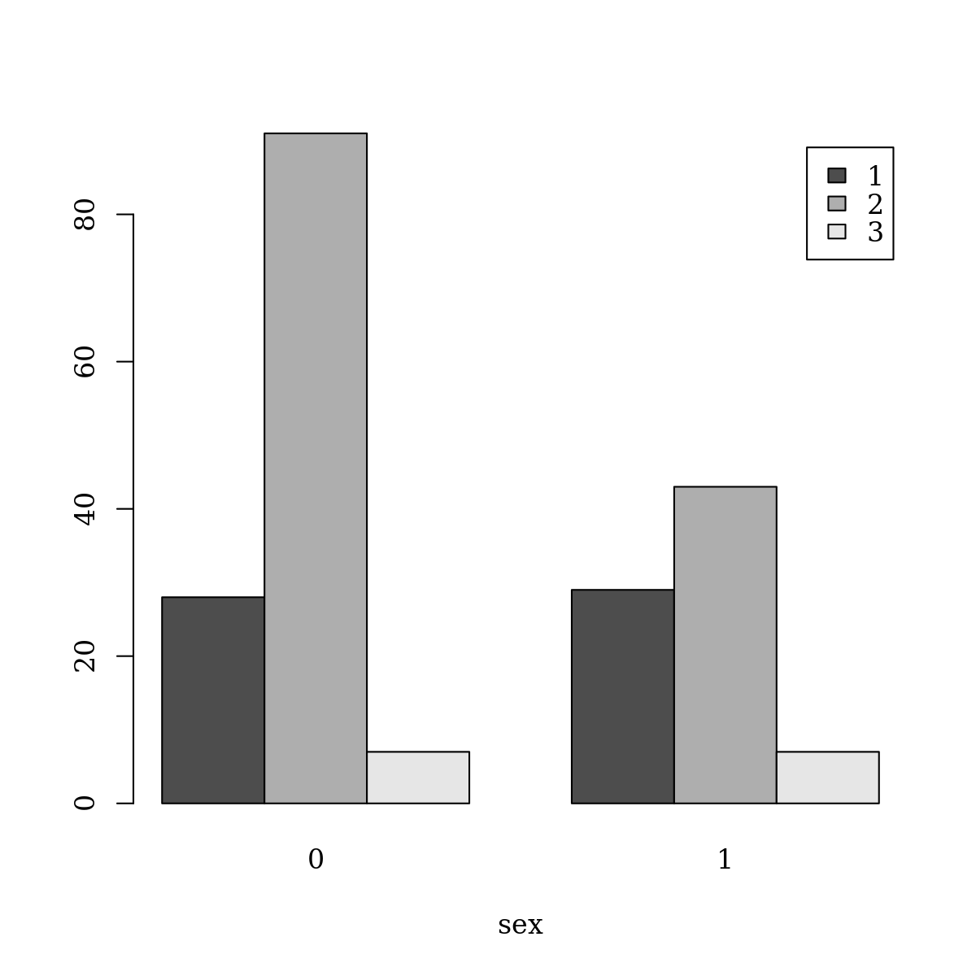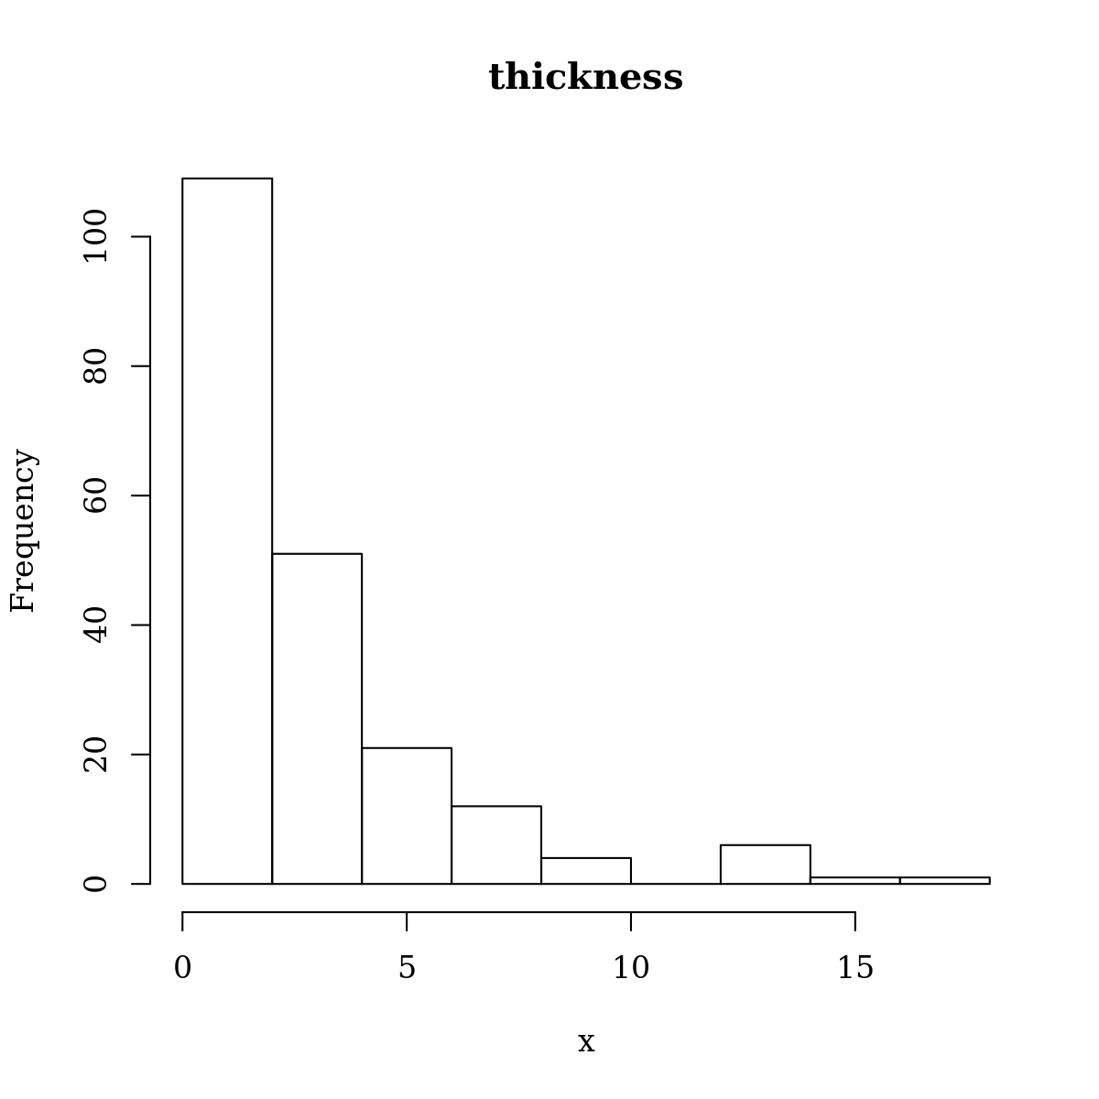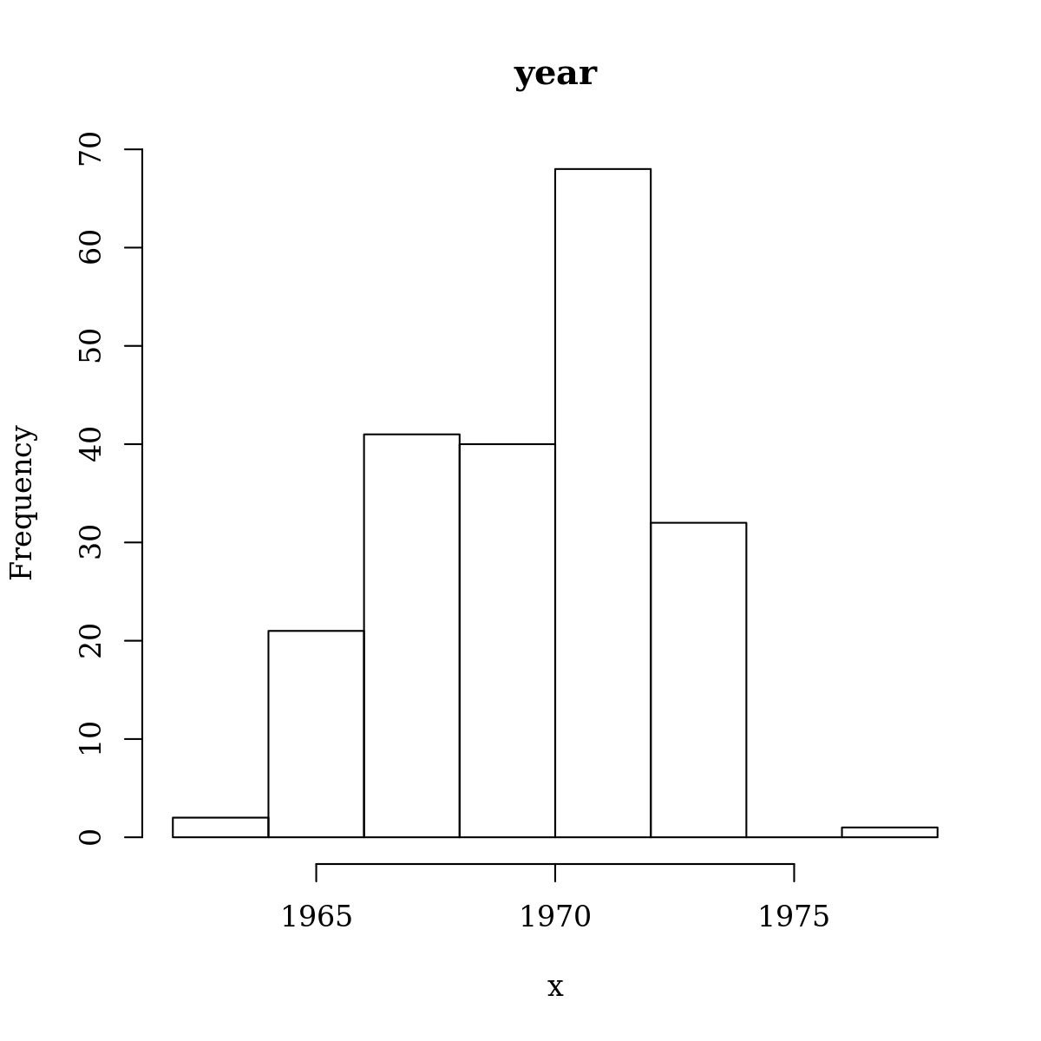

Figure 4

Bar-chart of sex showing the survival status of each gender

Figure 3

Distribution of tumour thickness in mm

Figure 3

Distribution of year of operation

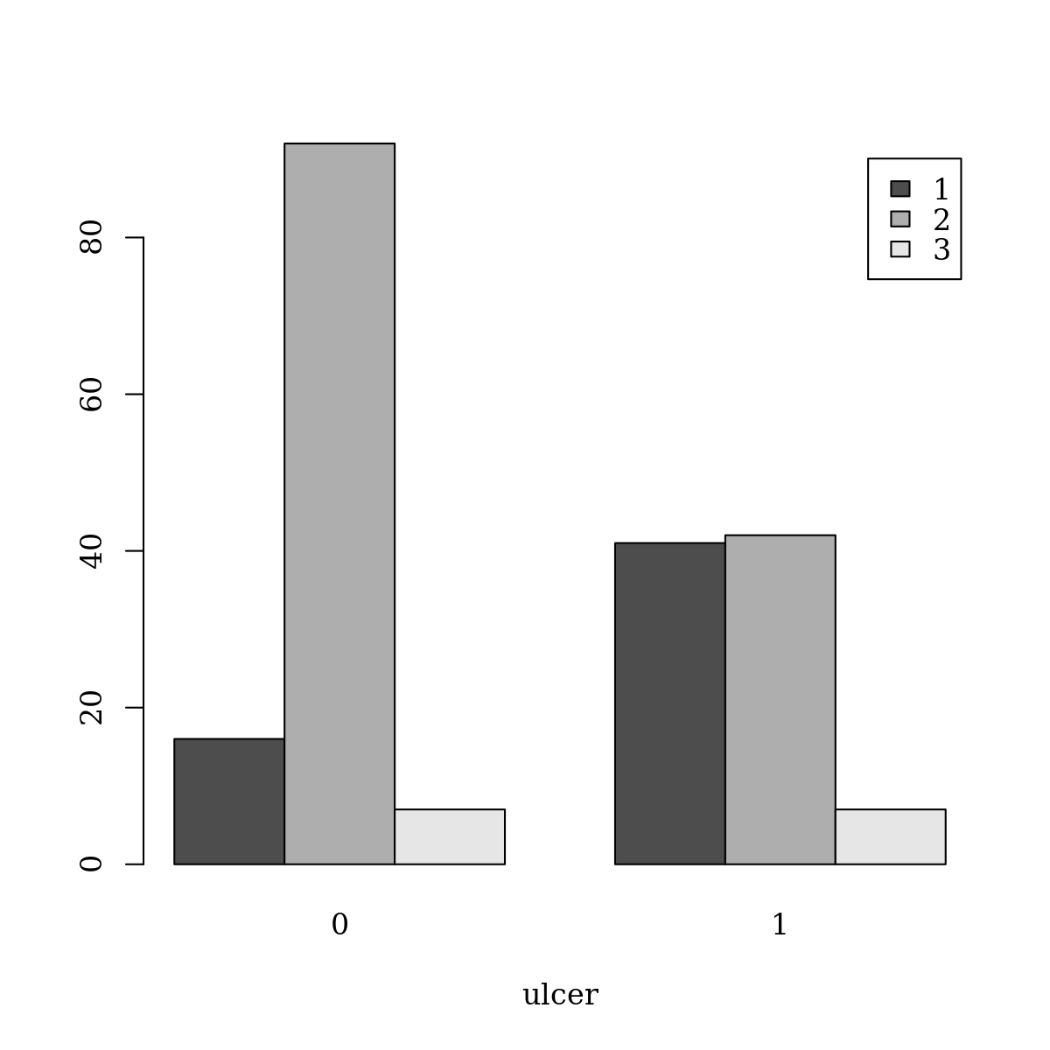

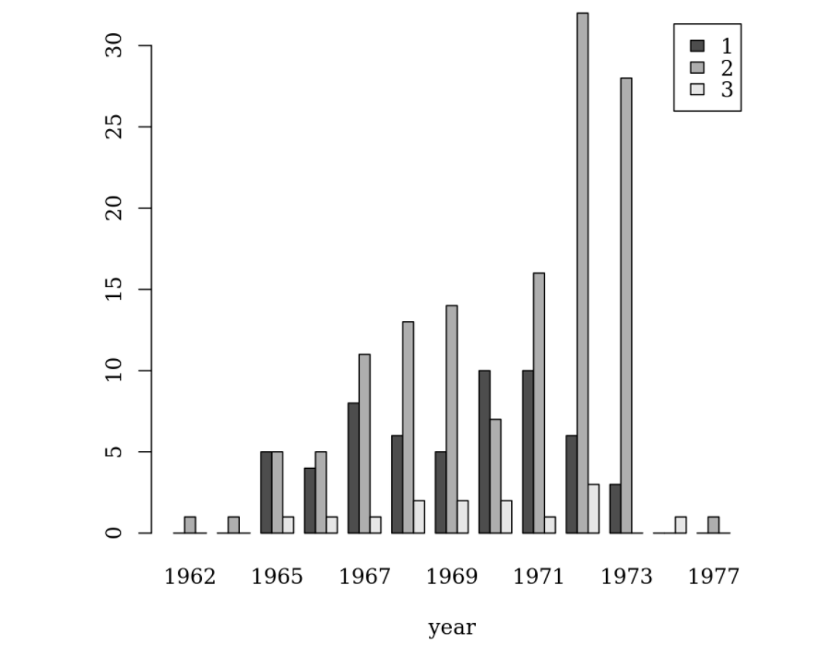

Commentary:

There's a noticeable increase in survival rate as years pass by, mortality rate is similar in both sexes and declining

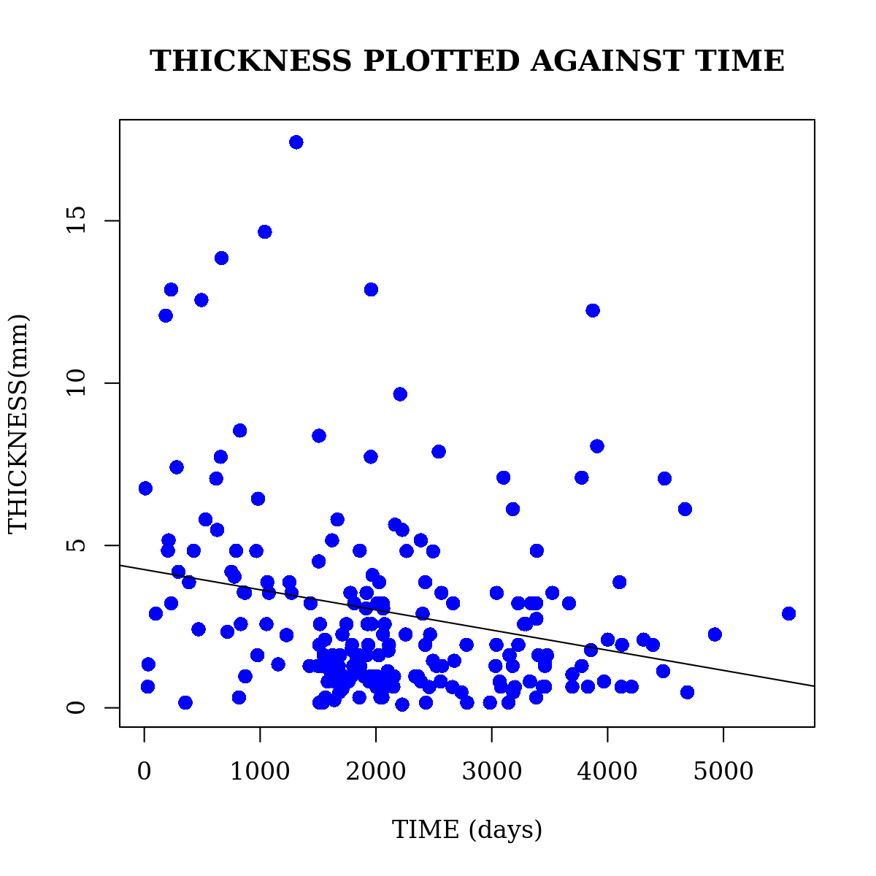**Solution 3 and 4**

Figure 6

From this figure it can be seen that tumour thickness (mm) has a **Negative Relationship** with survival time in days since the operation with R-square value of 0.055 and Pearson Correlation of -0.235

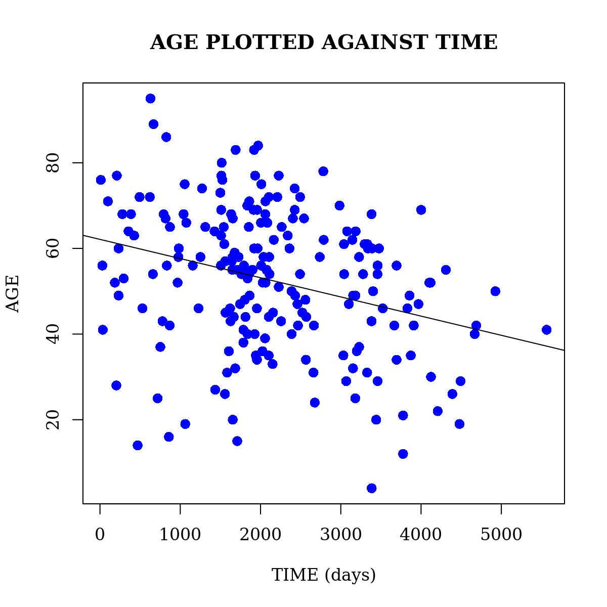

Figure 7

From this figure it can be seen that age in years at the time of the operation has a **Negative Relationship** with survival time in days since the operation with R-square value of 0.09 and Pearson Correlation of -0.302

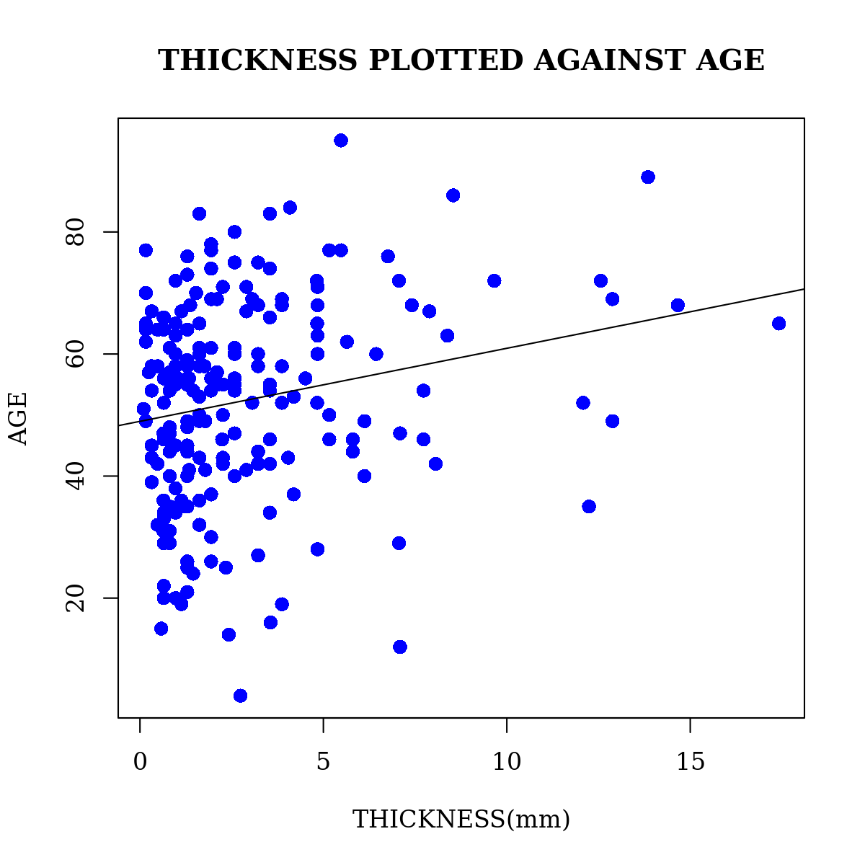

Figure 8

From this figure it can be seen that tumour thickness (mm) has a **Positive Relation** with the age in years at the time of the operation with R-square value of 0.05 and Pearson Correlation of 0.212

Commentary:

There are weak correlations between these variables

**Solution 5**

After grouping the data into two sample set based on the patient gender, T-test was carried out. T-tests are handy hypothesis tests in statistics when we want to compare means. We can compare a sample mean to a hypothesized or target value using a one-sample t-test.

From the result of the t-test carried out there was a high similarity between the gender group.

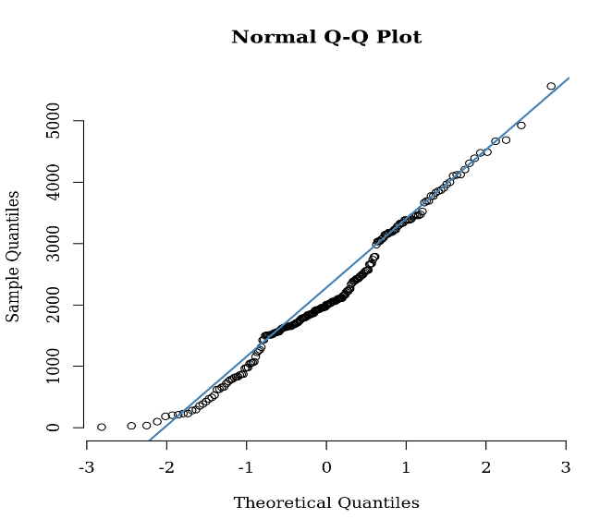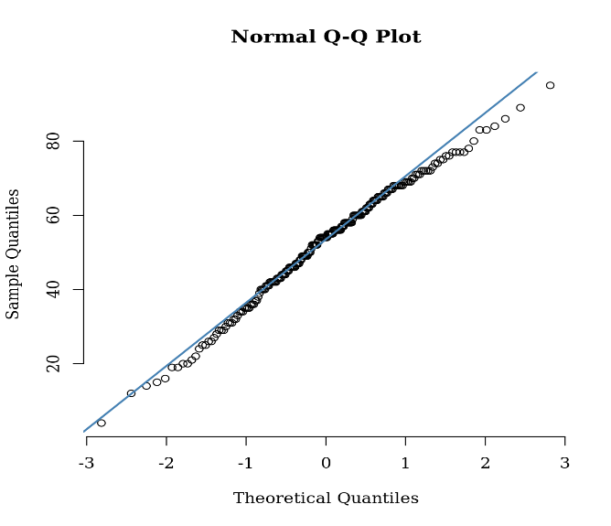**Solution 6**

Figure 10

Q-Q Plot for time, this graph indicates that the survival time in days since the operation is **Normally Distributed**

Figure 9

Q-Q Plot for age, this graph indicates that age in years at the time of the operation is **Normally Distributed**

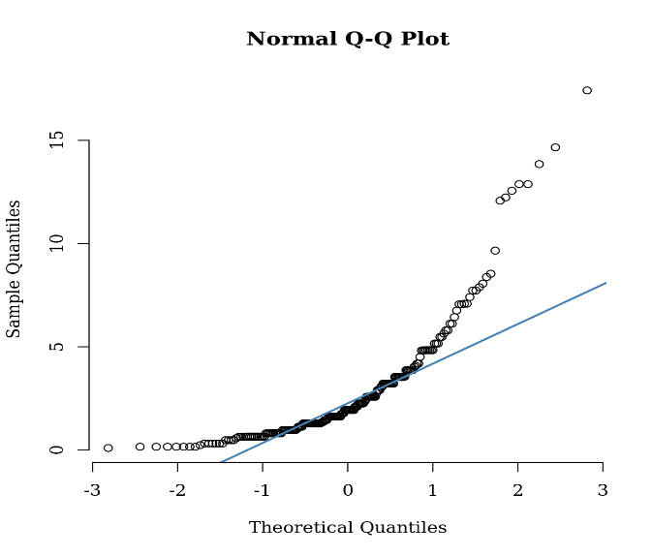

**Solution 7**

Figure 11

Q-Q Plot for tumour thickness, this graph indicates that the tumour thickness in mm. is **Exponentially Distributed**

In conclusion,

**Question 7**

In conclusion, it appears that patients with ulcerated tumors were older, more likely to be male, and had thicker stage tumors. Include these variables in the linear model.